 | - User Management & User Permissions in Linux

Name of Student | Hardik Prajapati | Roll No. | 9152
Sign here to indicate that you have read all relevant material provided /available on Moodle while performing and writing this experiment |  | Sign:

Late Submission Details (if any)
Reason(s) of late submission | Date of practical performance | Date of practical submission

References used
1 | Name and author of reference book(s) with page nos.
2 | Name and roll nos. of the peers whose help you have taken (if any)

Rubrics for assessment of Experiment:
Indicator | Poor | Average | Good
Timeliness  Maintains Experiment deadline (3) | Experiment not done (0) | One or More than One week late (1-2) | Maintains deadline (3)
Completeness and neatness  Complete all parts of Experiment (3) | N/A | < 80% complete (1-2) | 100% complete (3)
Originality  Extent of plagiarism (2) | Copied it from someone else (0) | At least try to implement but could not succeed (1) | Implemented (2)
Knowledge  In depth knowledge of the Experiment (2) | Unable to answer any questions (0) | Unable to answer few questions (1) | Able to answer all questions (2)

Assessment Marks:
Timeliness
Completeness and neatness
Originality
Knowledge
Total

Signature of Teacher with date

1. | Course, Subject & Experiment Details

Course & Branch | T.E. (ECS) | Estimated Time | 02 Hours Per Week
Current Semester | Semester VI | Subject Name | Linux Server Administration
Chapter No. & Unit | 2.3 | Chapter Title | Users, Groups, and Permissions
Experiment Type | Software Performance | Subject Code | ECL 604

2. | Aim & Objective of Experiment
- To study various Linux commands for user and group management
3. | Expected Outcome of Experiment
- To understand various Linux commands for new user creation, modification and deletion.
4. | Brief Description of the experiment

- Do the following tasks using appropriate commands:

- Change hostname as your “group no.”
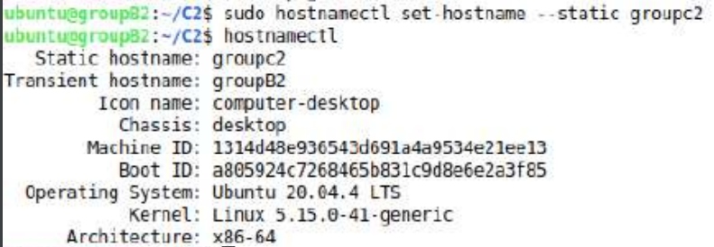
- Create a new user named “hduser” with account expiry date and password expiry date as 30-04-2023. Verify it.
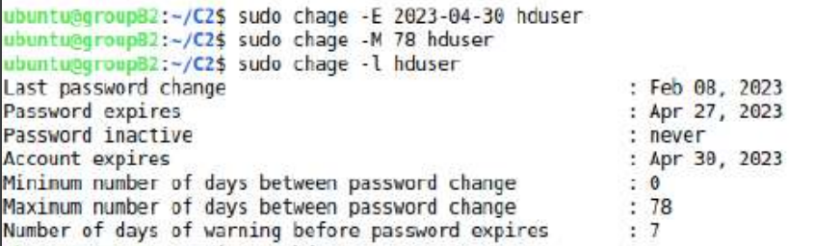

- Make sure that the above command has created the home directory of the user “hduser”. If not, create a directory with name as “hduser” and associate it with the user “hduser”
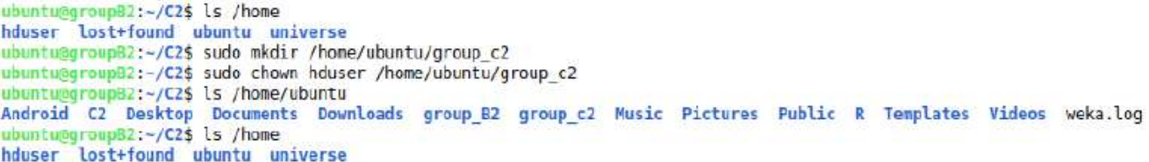

- Change the password of the user “hduser” as “123456”
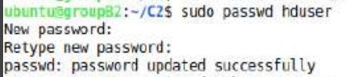

- Add a new group “myadmin”.
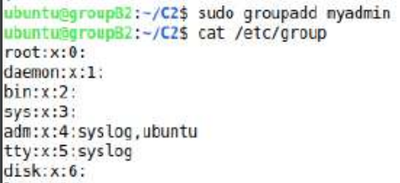
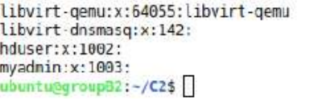

- Associate “hduser” with “myadmin”.
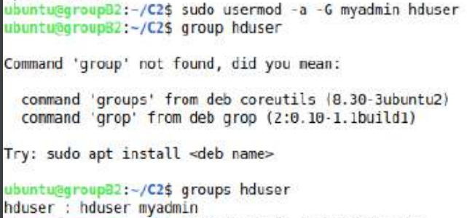

- Add all root permissions to the user “hduser” and the group “myadmin”

- Change the ownership of any one file in your home directory to “hduser”
- Verify the same
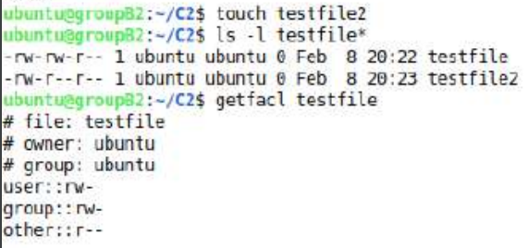

- Describe the usage of “umask” command with the help of an example, and show it practically
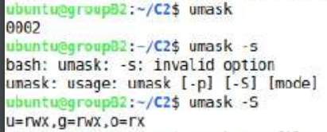

- Describe the usage of “acl” and “getfac” command, with the help od an example. Show it practically
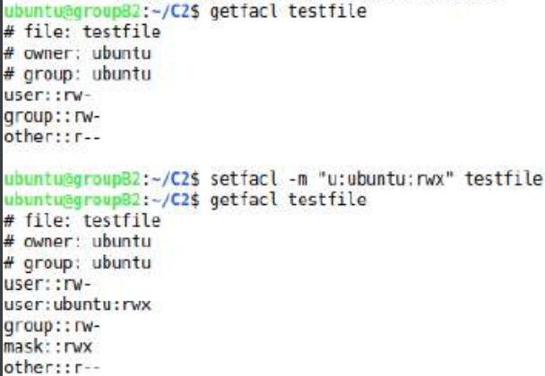

- Delete the user “hduser” and its all associated files.
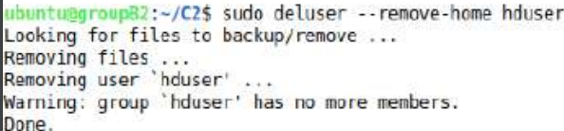
- Delete the group “myadmin”
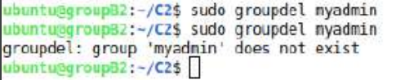

5. | Conclusions & Inferences
Learnt about various techniques of Linux for managing the username. And performed various
Linux commands to make new user, delete user and also changing the permission of user.

6. | Post Lab exercise

- Modify the permissions (of your choice) of the user “hduser” using appropriate Linux command.
